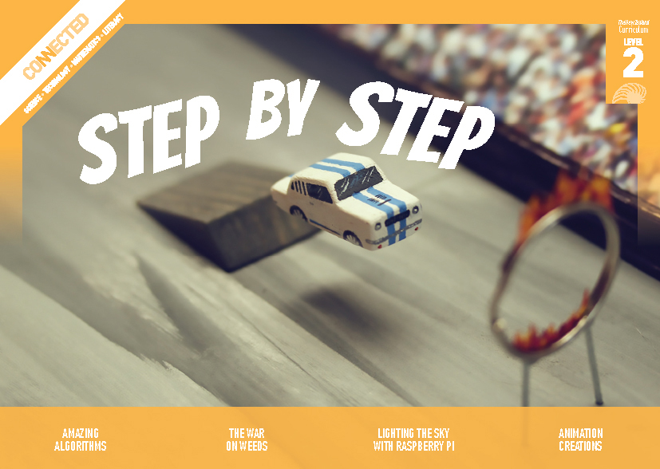
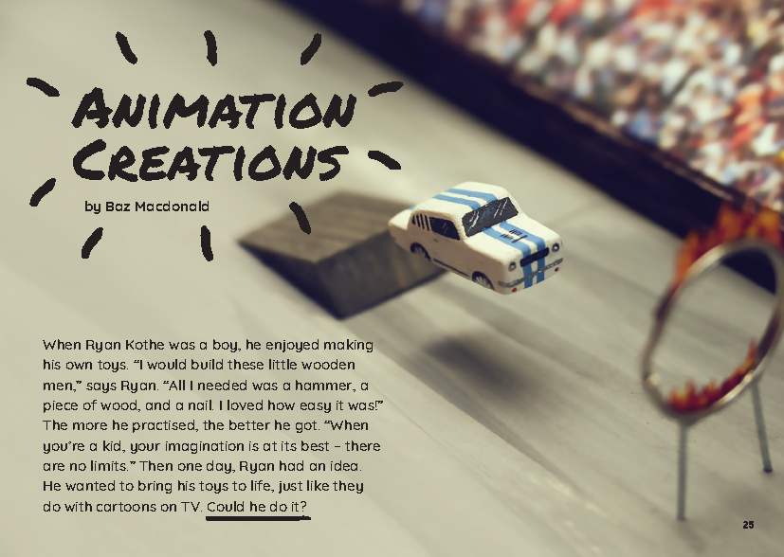
Connected
Level 2
2018

Animation Creations
by Baz Macdonald

Overview
This article describes how Ryan Kothe, an animator from Auckland, uses stop-motion animation to make short videos and advertisements. It uses an accessible, interesting, and low-cost example to demonstrate how to create, manipulate, and store digital content.
A Google Slides version of this article is available at www.connected.tki.org.nz
This text also has additional digital content, which is available online at www.connected.tki.org.nz
Curriculum contexts

TECHNOLOGY: Technological Practice: Planning for practice  Level 2 – Students will develop a plan that identifies the key stages and the resources required to complete an outcome.  TECHNOLOGY: Technological Practice: Brief development  Level 2 – Students will explain the outcome they are developing and describe the attributes it should have, taking account of the need or opportunity and the resources available.  Designing and developing digital outcomes: Progress outcome 1  In authentic contexts and taking account of end-users, students participate in teacher-led activities to develop, manipulate, store, retrieve, and share digital content in order to meet technological challenges. In doing so, they identify digital devices and their purposes and understand that humans make them. They know how to use some applications, they can identify the inputs and outputs of a system, and they understand that digital devices store content, which can be retrieved later. | Key technology ideas  - Stop-motion animation is the process used to “move” inanimate objects.  - Planning is the first step in the process.  - Software can be used to change or enhance a recorded video.
ENGLISH: Reading  Level 2 – Ideas: Students will show some understanding of ideas within, across, and beyond texts. | Indicators:  - uses their personal experience and world and literacy knowledge to make meaning from texts  - makes meaning of increasingly complex texts by identifying main ideas  - makes and supports inferences from texts with some independence.

MATHEMATICS and STATISTICS: Number and Algebra – Patterns and relationships  Level 2 – Students will find rules for the next member in a sequential pattern. | Key mathematics ideas  - Stop-motion animation is a sequence or pattern of images designed in a set way or with a rule in mind to tell a story.

The New Zealand Curriculum

Technology

Meeting the literacy challenges

The main literacy demands of this text lie in the requirement for students to interpret photographs and a storyboard to follow Ryan’s process for creating an animation. There is a lot of information to connect across the text. However, the headings provide clear direction and the sequence words clearly indicate what happens when.  The text contains a lot of technical vocabulary, but most of it is explained. Photos clarify information and concepts. Those on page 31 invite the reader to make connections with the storyboard on page 29. | The following strategies will support students to understand, respond to, and think critically about the information and ideas in the text. It may be appropriate to use all or only one or two of these strategies, depending on your students’ literacy knowledge and skills. You are encouraged to reword the suggested questions that will best suit your learners’ strengths and needs.  You may wish to use shared or guided reading, or a mixture of both, depending on the reading expertise of your students and the background knowledge they bring to the text.  After reading the text, support students to explore the activities outlined in the following pages.

INSTRUCTIONAL STRATEGIES

Finding the main ideas  Have the students read the introduction. PROMPT them to make connections to their prior knowledge of cartoons by asking them to think, pair, and share their predictions about how Ryan might “bring his toys to life”.  Have the students read page 26 to check their predictions. Clarify that animation is another word for cartoon.  Check that the students understand the “Moving pictures” sidebar. If they are unsure, give them a pad or some sticky notes that they can use to make a simple flip book (see the resource links for support).  Confirm that the article tells us how to make a stop-motion animation. Check that the students understand what stop-motion is. EXPLAIN that a text that tells us how to do or make something is called a procedural text. PROMPT the students to share examples of procedural texts with which they are familiar (for example, a recipe or rules for a game) and to recall their features. These include:  - a title or goal  - a list of materials or ingredients  - step-by-step instructions  - action words  - words or numbers to show the sequence  - often pictures or diagrams.  Reinforce the importance of sequence words or numbers in a procedural text. Have the students:  - review pages 29 and 30 and identify the sequence words (the words that tell us when something happened)  - scan the article again to identify the key steps in making an animation.  EXPLAIN that this particular procedural text includes a narrative with extra information, so it is longer than other procedural texts that stick to the basic instructions.  Work with the students to create a Google doc to RECORD the procedure for making stop-motion animations. Model and EXPLAIN how to omit the narrative and focus on the actual procedure (the basic instructions). | As the students read, have them note the words and phrases that indicate the main actions and those that indicate sequence. Help them to understand that sometimes there are steps within the steps. (This is especially clear on page 30.) Encourage them to challenge each other to differentiate the key steps in the procedure from other information that isn’t strictly necessary.  After the reading, have the students critically analyse their procedures, imagining that they are novice animators who need to create a stop-motion animation. (This will be more effective if the students will actually make a stop-motion animation!)  Evaluating the language features  Discuss why the author has chosen to present the information the way he has.  Why didn’t the author just give us a straightforward procedural text? What did we gain and what did we lose by focusing on the most essential points?  Can you think of other ways the writer could have shared the information? What are the advantages and disadvantages?  What about all that helpful advice? How could we record that so it isn’t lost?  If you’re intending to follow up by having the students create their own animations, have them work in groups to IDENTIFY and RECORD the advice that takes us beyond the basic procedure for making an animation. This information offers tips for improving the quality of the animation.  Using design features for deeper understanding  EXPLAIN that each of the photographs provide information to support the text. For example, on page 32, the close-up photographs show us the way Ryan uses tools like scalpels and tweezers to create the tiny details that make the scenes work. It reinforces the importance of starting small and the need to “be patient and work carefully”.  Look closely at each of the photographs. How do they relate to the information in the text?  What do we get from the photographs that we wouldn’t get from just reading the words?

Meeting the literacy challenges

TEACHER RESOURCES

Want to know more about instructional strategies? Go to:  - http://literacyonline.tki.org.nz/Literacy-Online/Planning-for-my-students-needs/Effective-Literacy-Practice-Years-1-4  - “Engaging Learners with Texts” (Chapter 5) from Effective Literacy Practice in Years 1 to 4 (Ministry of Education, 2003).  Want to know more about what literacy skills and knowledge your students need? Go to:  - http://nzcurriculum.tki.org.nz/Assessment/Reading-and-writing-standards  - http://www.literacyprogressions.tki.org.nz/ | We have retained the links to the National Standards while a new assessment and reporting system is being developed. For more information on assessing and reporting in the post-National Standards era, see:  - http://assessment.tki.org.nz/Assessment-and-reporting-guide

Reading standard: by the end of year 4
The Literacy Learning Progressions
Effective Literacy Practice: years 1–4

Illustrating the key ideas

TEACHER SUPPORT
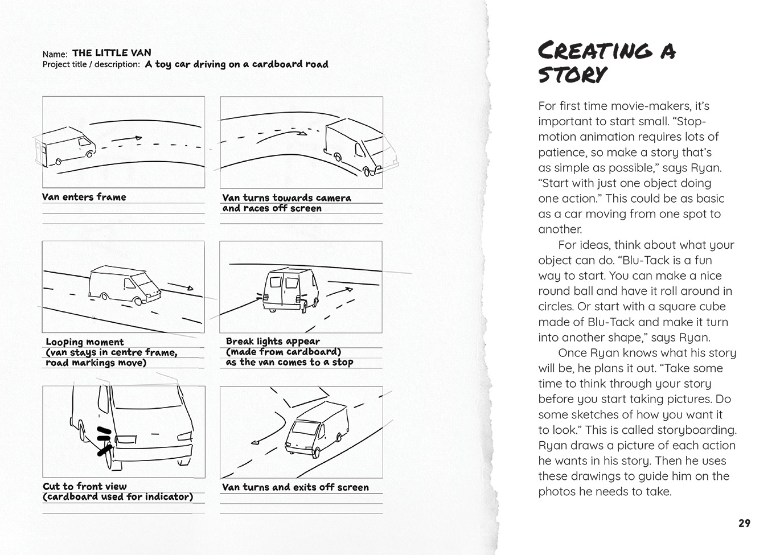  Stop-motion animation is a sequence or pattern of images designed in a set way to tell a story. |  | Stop-motion animation is used to ‘move’ inanimate objects.  Planning is the first step in the stop-motion animation process.
 | [Grab your reader’s attention with a great quote from the document or use this space to emphasize a key point. To place this text box anywhere on the page, just drag it.]

Learning activities – Exploring the technology
and mathematics and statistics
The following activities and suggestions are designed as a guide for supporting students to explore and extend student content knowledge across the learning areas. Adapt these activities to support your students’ learning needs.

Activity 1 – Persistence of vision  The students could make simple flip books and use them to investigate whether there is a rate at which their brain sees a sequence of images as a single moving object rather than as a series of still images.  Does the rate vary depending on the nature of the image?  Is it different for different people?  The students will find that there is little discernible difference between different people’s experiences – the human eye and brain can only process ten to twelve images per second. That means we keep seeing the image of an object for a brief period after the object has gone. Explain that this phenomenon is called “persistence of vision” and it is the principle on which animation is based.  The resource links include introductions to this phenomenon. There are also ideas for creating thaumatropes – scientific toys based on this phenomenon that were popular in the nineteenth century.  When you’re sure the students have understood the optical illusion, have them review the article.  The article doesn’t use the term persistence of vision, but what does it have to say about it?  How would you compare your personal experiences of viewing a movie with lots of frames per second to a simple animation that may not have many?  Have the students use this information to calculate:  - the number of frames per second needed in a flip book that everyone would enjoy  - the number of frames needed for a three-minute movie, assuming you want ten frames per second  - the number of frames needed for a five-minute movie.  The students can now use this calculation when they create their own digital animations. | Activity 2 – Animation action  Tell the students that they are going to make animations of their own. Have them review the procedure they created while reading the article, along with their records of key points to remember. Show them the video of Ryan’s finished animation available as part of the additional digital content on Google Slides.  Have the students move into groups to start planning their animations. The table below offers some tips, referencing the subheadings in the article. As the students work, keep prompting them to think about the procedures they have developed and what they have learnt about making a successful animation.  Getting ready Play some stop-motion animations for the students. Have them critically analyse them, looking for lessons they can apply when they create their own. What do you notice about these animations that reflects some of the key points we learnt from the article? What do you notice about the lighting? The camera angles? The pace – and what it suggests about the number of frames per second? What do you like or dislike about these animations? Why? What does this suggest to you about creating an animation? What ideas do you get when viewing other people’s animations? Teacher support: Christina Fortes at New Lynn School enjoys showing her students how they can use digital technologies in smart and creative ways. A story on The New Zealand Curriculum Online describes what she is doing. It includes examples of stop-motion animations that her students have created.  Purpose Discuss the purpose of the animations and who the audience might be. Do we have a point that we want to make? Is there an issue we are concerned about? A problem we want people to be aware of? Are there people we want to entertain? Do we want to share our response to music? Tell a story? Make people laugh? Have we learnt something recently that we think other people should know about? A concept from our learning in mathematics? A process we have learnt about in science?

Activity 2 – Animation action (continued)

Materials | Give the students the opportunity to become familiar with the software and hardware they will use. Consider where you could get expert help if this is something new to you.
Choosing an object | Stikbot has toys students can use to create their animations and Toontastic gets them started with scenes and characters. However, as the article shows, students can make their own and keep them very simple. They could even take photos of each other.
Creating a story | Consider using the Ministry of Education’s Story Starters for Boys as a catalyst for conceptualising, planning, and writing the stories.
Setting up | Lifewire describes five things to do before you start animating, emphasising the importance of careful planning so you don’t put a lot of time and effort into going down the wrong path.
Taking photos | The camera shots lesson plan from Media Smarts is for older students, but you could adapt the ideas to help your students experiment with different camera techniques.
Putting it together | The resource links include websites where you can find advice on free or inexpensive apps. You’ll want to select something relatively simple. Again, if you’re feeling hesitant, there could be people in your community who could help you make your selection and start getting to grips with what your chosen app can do.  Foley artists use physical props to make sound effects for scenes after they’ve been filmed. The students could experiment with different techniques for creating their own sound effects.
Making movies | Animation is a skill that could be applied across the curriculum. It could be used to retell a story in English or make a convincing point in social studies. For some students, it might be a career choice, as it was for Ryan. Have the students reflect on how he made his boyhood dream become a reality and what they might have to do to make it happen for them.

Learning activities – Exploring the technology and mathematics and statistics

RESOURCE LINKS

New Zealand animators  Ryan Kothe  Wield – Worn Out (vimeo): https://vimeo.com/18576667  Clip 1 – Ryan Kothe (vimeo): https://vimeo.com/59946281  Stuntman Jimmy & the Flaming Keyring (Wield): https://vimeo.com/31998899  Antony Elworthy  Antony Elworthy: https://antonyelworthy.com/  Newshub – The Kiwi animator behind Wes Anderson’s Isle of Dogs: www.newshub.co.nz/home/entertainment/2018/05/the-kiwi-animator-behind-wes-anderson-s-isle-of-dogs.html  RNZ – The stop-motion world of Antony Elworthy: www.radionz.co.nz/national/programmes/standing-room-only/audio/2018637708/the-stop-motion-world-of-antony-elworthy  Flipbooks  How to make a flipbook: www.youtube.com/watch?v=Un-BdBSOGKY  Wiki How – How to make a flipbook (drawing and using video): www.wikihow.com/Make-a-Flipbook  Persistence of vision  Persistence of vision – How does animation work?: www.futurelearn.com/courses/explore-animation/0/steps/12222  What is persistence of vision? (Mr Wizard): www.youtube.com/watch?v=YismwdgMIRc  Persistence of vision: www.youtube.com/watch?v=bcstc1ozczQ  Persistence of vision: https://funbrains.net/persistence-of-vision/ | Animation and movie-making apps  Free Apps for Me – 10 Best stop motion apps for Android & iOS: https://freeappsforme.com/stop-motion-apps/  iMotion (app) – How to use iMotion: www.youtube.com/watch?v=BHjbEGe6E9I  Slowmation: www.slowmation.com/  StikBot Studio – app tutorial video: www.youtube.com/watch?v=uF0Qdx-oaoQ  StikBot Central (YouTube): www.youtube.com/channel/UCPHXb7eJeUED2MBaBXm4c5Q  Zing StikBot Studio (app for moviemaking): https://play.google.com/store/apps/details?id=com.zingglobal.stikbot  Toontastic (app): https://toontastic.withgoogle.com/  Other sources  Thaumatropes – Unit 33: Stop-motion animation techniques research: www.youtube.com/watch?v=yOLE2OzoIYw  How to make thaumatrope (2 types): www.youtube.com/watch?v=5kZt7Xxntug  Animation Mentor – How to become an animator: http://content.animationmentor.com/pdfs/AnimationMentor_HowToBecomeAnAnimator.pdf  Great Big Story – The magical realism of Foley artists |That’s amazing: www.greatbigstory.com/stories/foley-artists-that-s-amazing  Lifewire – 5 Things to do before you start animating: www.thoughtco.com/before-you-ever-start-animating-140943  Media Smarts – Camera shots lesson plan: http://mediasmarts.ca/sites/mediasmarts/files/pdfs/lesson-plan/Lesson_Camera_Shots.pdf  Ministry of Education – Story starters: https://success-for-boys.tki.org.nz/Teaching-learning-resources/Story-Starters  TKI case study – New Lynn School: http://nzcurriculum.tki.org.nz/Curriculum-stories/School-snapshots/New-Lynn-School

